**CODE AND OUTPUT ARRAY EXERCISES**

1.

**package** ArrayOneDimensional;

**public** **class** Exercise1 {

**public** **static** **void** main(String[] args) {

// Declare an array alpha of 15 element of type integer

**int**[]alpha = {1,2,3,4,5,6,7,8,9,10,11,12,13,14,15};

**int**[]beta = **new** **int**[20];

//Output the value of 10 element of the alpha array

System.***out***.println(alpha[9]);

//Set the value of the 5 element of the alpha array to 35

alpha[4] = 35;

System.***out***.println(alpha[4]);

//Set the value of the 9 element of the alpha array to the sum of the 6 n 11

alpha[8] = alpha[5] + alpha[12];

System.***out***.println("Sum = " + alpha[8]);

}

}

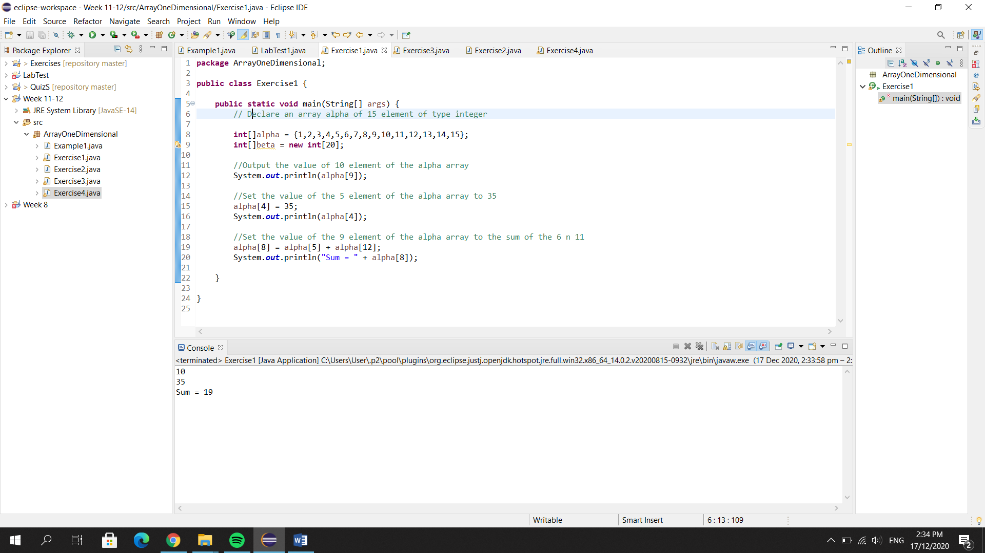

2.

**package** ArrayOneDimensional;

**public** **class** Exercise2 {

**public** **static** **void** main(String[] args) {

//write a statement that declare a string array initialize with the following string:

//sunday, monday, tuesday, wednesday, thursday, friday, saturday

//write a loop that disp content of each element in the array that u declared

String[]days = {"Sunday", "Monday", "Tuesday", "Wednesday", "Thursday", "Friday", "Saturday"};

**for** (**int** i=0; i<days.length; i++){

System.***out***.println(days[i]);

}

System.***out***.println();

**int** j = 0;

**while**(j<days.length) {

System.***out***.println(days[j]);

j++;

}

System.***out***.println();

**int** k = 0;

**do** {

System.***out***.println(days[k]);

k++;

} **while** (k<days.length);

}

}

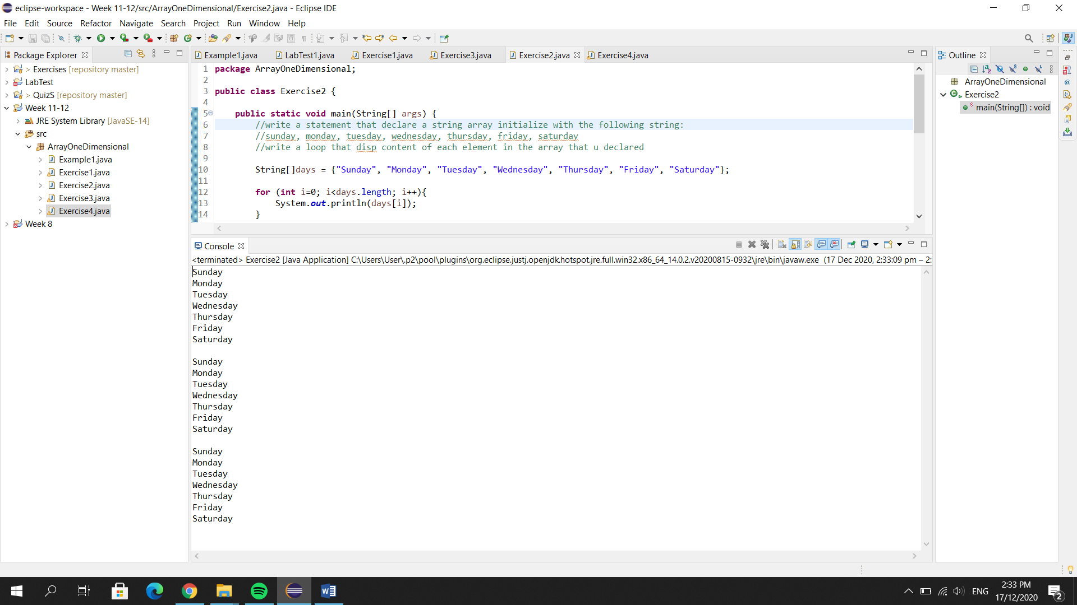

3.

**package** ArrayOneDimensional;

**import** java.util.Scanner;

**public** **class** Exercise3 {

**public** **static** **void** main(String[] args) {

//Write a program that create an array of 10 element size. ur program should promt the users to input no in array

//Display the sum of all array element

**final** **int** num = 10;

**int**[]numbers = **new** **int**[10];

Scanner sc = **new** Scanner (System.***in***);

System.***out***.print("Enter numbers: ");

**for** (**int** i=0; i<numbers.length; i++) {

numbers[i] = sc.nextInt();

}

**int** sum=0;

**for**(**int** i=0; i<numbers.length; i++) {

sum = sum + numbers[i];

}

System.***out***.println("Sum numbers: " +sum);

sc.close();

}

}

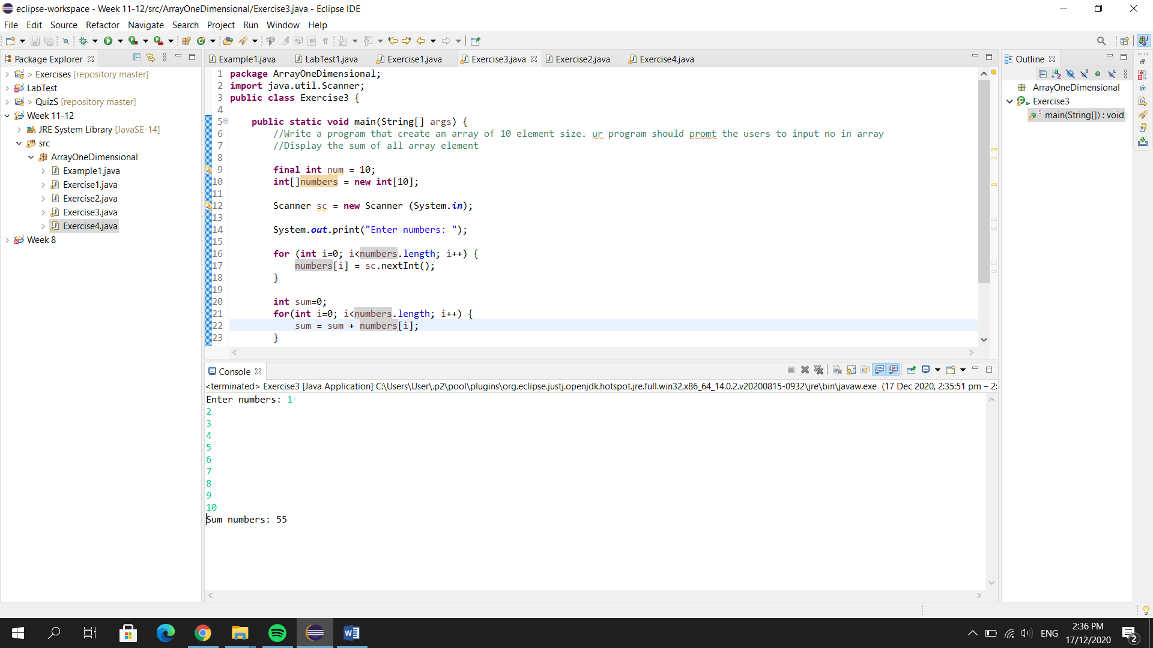

4.

**package** ArrayOneDimensional;

**import** java.util.Scanner;

**public** **class** Exercise4 {

**public** **static** **void** main(String[] args) {

Scanner sc=**new** Scanner(System.***in***);

**int**[] list1=**new** **int**[5];

**int**[] list2=**new** **int**[5];

System.***out***.println("Enter 5 numbers: ");

**for**(**int** i=0;i<list1.length;i++) {

list1[i]=sc.nextInt();

}

**for**(**int** i=0;i<list2.length;i++) {

list2[i]=list1[i];

}

System.***out***.println();

System.***out***.println("List 1:");

**for**(**int** i=0;i<list1.length;i++) {

System.***out***.println(list1[i]);

}

System.***out***.println();

System.***out***.println("List 2:");

**for**(**int** i=0;i<list2.length;i++) {

System.***out***.println(list2[i]);

}

sc.close();

}

}

